Roy and Profile Picture
Platform: HackerEarth
Language: C
Module 2, Question 4

Problem Link
https://www.hackerearth.com/practice/basic-programming/input-output/basics-of-input-output/practice-problems/algorithm/roy-and-profile-picture/

Problem Statement
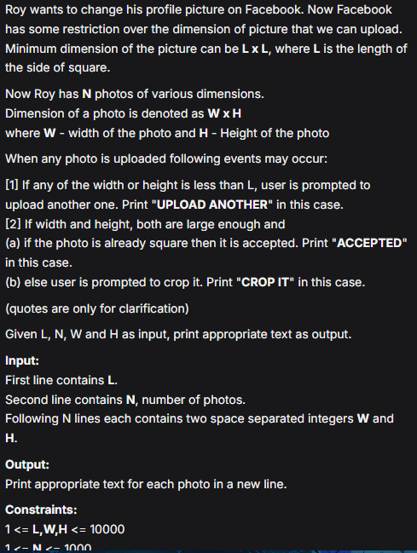

C Code
#include <stdio.h>

int main() {
int l, n;
scanf("%d", &l);
scanf("%d", &n);

for (int i = 0; i < n; i++) {
int w, h;
scanf("%d %d", &w, &h);

if (w < l || h < l)
printf("UPLOAD ANOTHER\n");
else if (w == h)
printf("ACCEPTED\n");
else
printf("CROP IT\n");
}
return 0;
}

Screenshot of Successful Submission



